[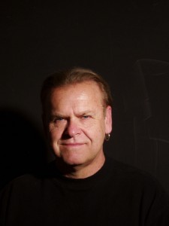](http://dev.chuckbankutiphotography.com/wp-content/uploads/2012/06/Head-shot-for-press-photo1.jpg)

Photography is the artistic expression that Chuck Bankuti was immediately drawn to after realizing that he could capture incredible moments as he saw them! His understanding of composition and light is clearly evident in his extensive body of photographic work displayed on this website.

Chuck, over many decades of hard work, has mastered the many categories in photography. He worked in Los Angeles for some of the most well known advertising agencies. His work covered ad campaigns, editorials and magazine covers. For many years he was involved in photographing some of the most well known celebrities in the last 30 plus years. His work in the studio would lead to some of the most memorable celebrity images of our time. His celebrity assignments done in the studio or on location included magazine covers and editorials which were published in magazines all over the world.

Beauty and Fashion is a specialized field in photography and another opportunity in which Chuck excels, he worked for top clothing designers, creating ads and doing editorials for numerous magazines published worldwide. During this period he had the privilege of working with the top makeup, hair and clothing stylists.

Throughout his career he has been involved in working with artists of many Medias ranging from ceramic and marble sculpture, painting, wood carving, print making and photography. He photographed their work for exhibits, the internet as well as portraits of the artist themselves. Many lifelong friendships have developed from these working relationships.

His work in the fine art photographic field speaks for itself. After many decades this has led to an extensive body of work which is now sought after by collectors.