Chuck Bankuti was born in Hungary just outside of Budapest. [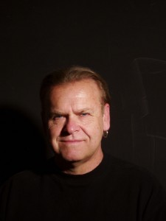](http://dev.chuckbankutiphotography.com/wp-content/uploads/2012/06/Head-shot-for-press-photo1.jpg)

His early years had a connection with the spectacular beauty of nature which would in turn lead him into photography. Photography was something he immediately was drawn to after realizing that he could capture incredible moments in time! This is clearly evident in his extensively wide body of photographic work displayed today.

Chuck over many decades of hard work has mastered many areas in photography. He worked in Los Angeles for some of the most well known advertising agencies. His extensive work covered ad campaigns, editorials and magazine covers.

For many years Chuck was involved in photographing some of the most celebrated celebrities of our time. His work in the studio would lead to some of the most timeless images. His celebrity assignments on location would be published in magazines all over the world, this included magazine covers and editorials. Chuck was hired to set up a studio on the sound stage of major Hollywood Studios, and do stills of the celebrities on a number of big budget Hollywood movies.

Beauty and Fashion is the field that all photographers wish to work in and Chuck worked in this field in Los Angeles for top clothing designers, creating ads and doing editorials for numerous magazines published worldwide. I had the privilege of working with the top makeup, hair and clothing stylists.

Throughout his career he has been involved in working with Artist of many Medias. They range from ceramic and marble sculpture, painting, wood carving, print making and photography. He has photographed their work as well as the artists themselves. Many working relationships have led to lifelong friendships.

Chuck has worked in the fine art photographic field for many decades and this has led to an extensive body of work which is now sought after by collectors.

Chuck over many decades has used many camera formats and techniques and still prefers to use a blend of film and digital imagery. He has worked in the following fields of photography, fine art, advertising, celebrities, motion picture stills and with artists in various Medias. Working with Painters and Sculptures over a 42 year period has greatly influenced how he approaches and executes his work. The Native American projects have evolved over a span of 20 years. During this time he has had the privilege of documenting their culture and their ancestral lands. Native Americans have allowed him to not only understand their culture but to extensively photograph it. In the process they have given him a greater spiritual understanding of their beliefs and culture.